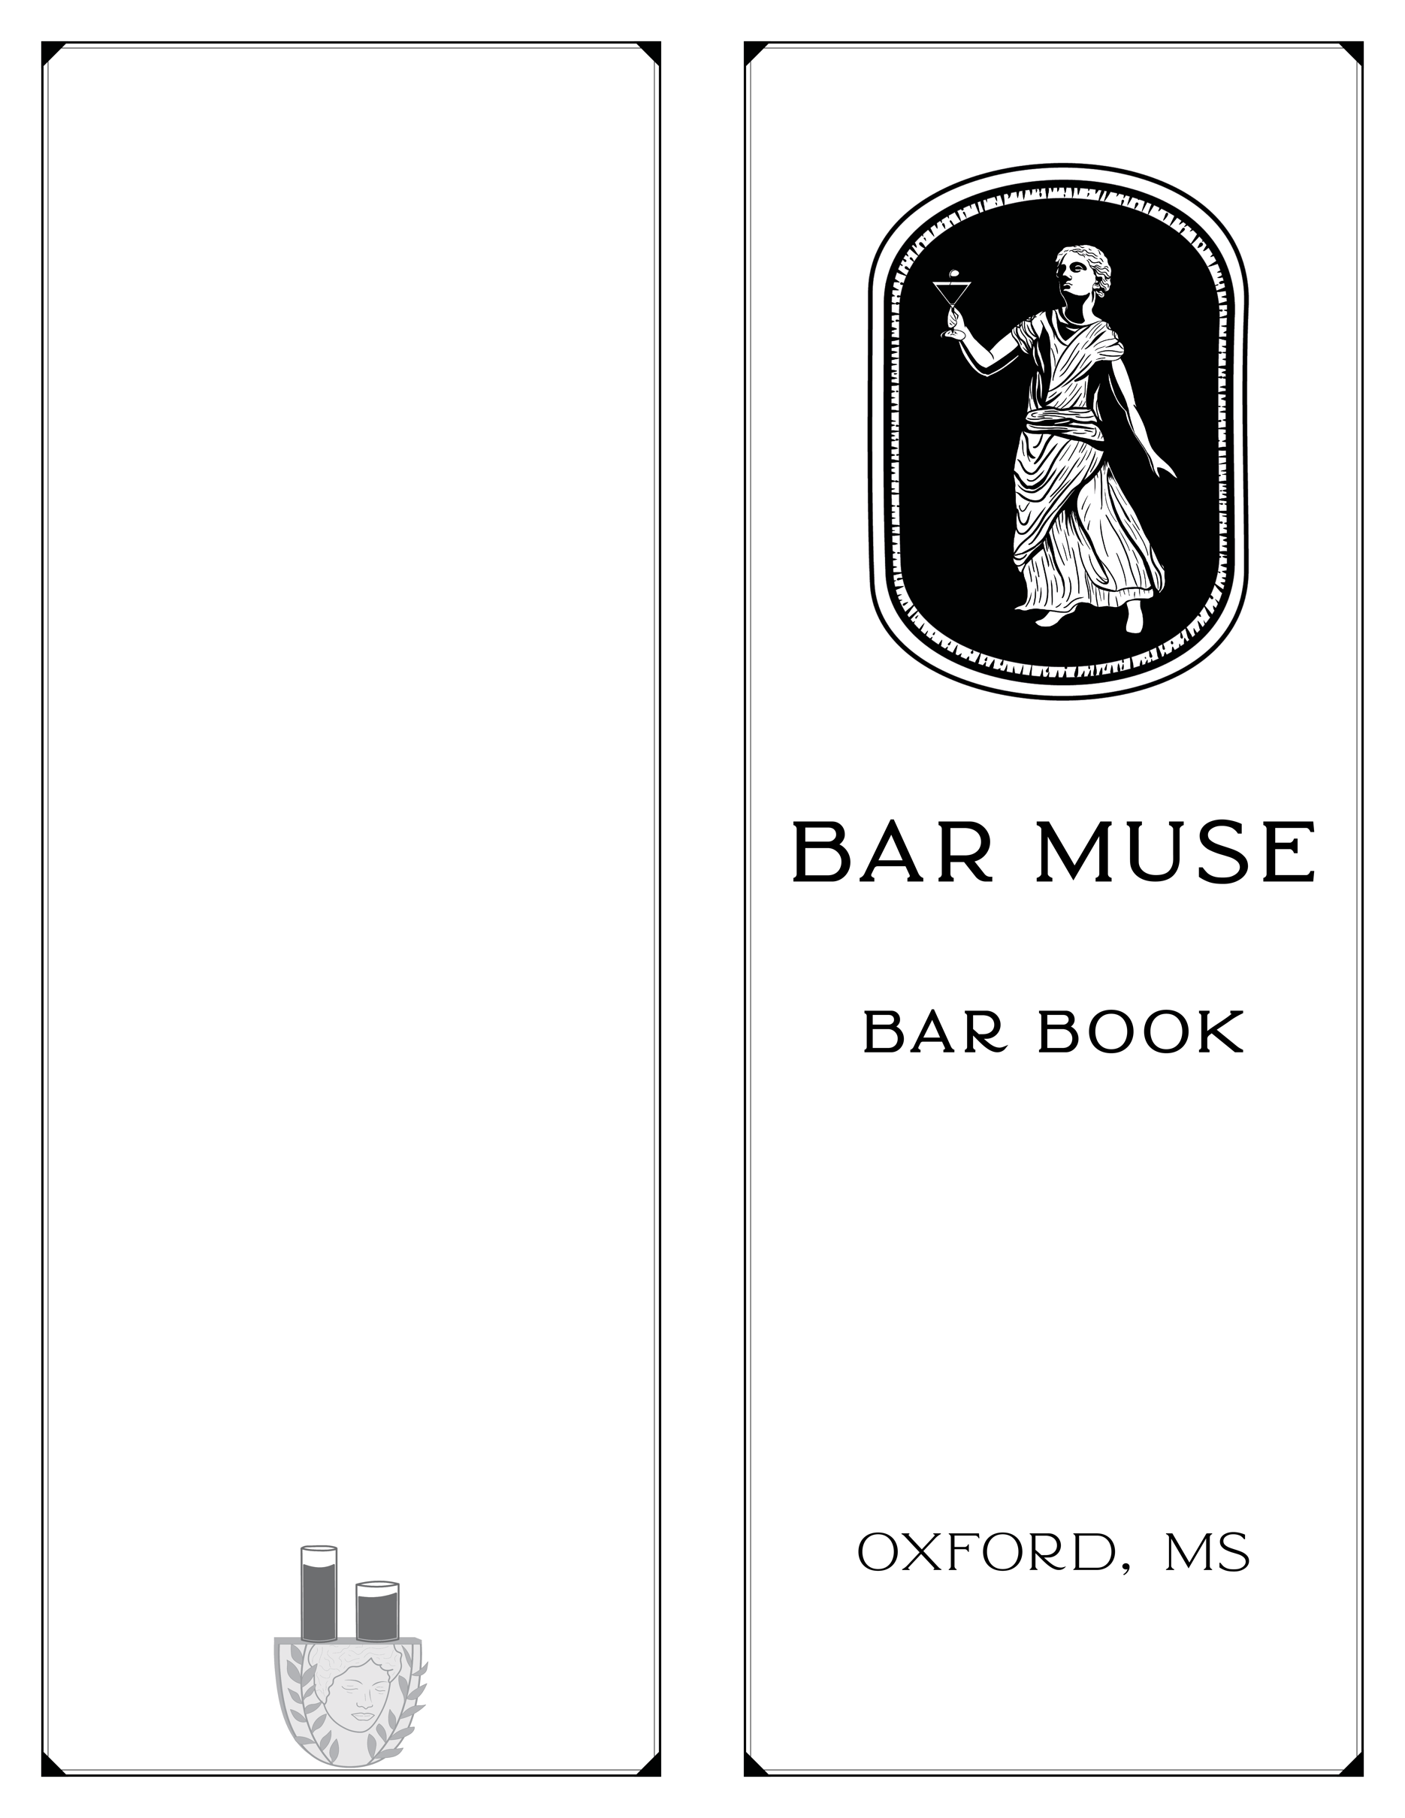

**About This Menu**

Oxford winters—the interim season between oxford’s favorite’s seasons, football & baseball. While the weather outside may be cold, allow these drinks to warm your spirits. Our menu features winter produce such as satsumas & persimmons. The wine list features some exciting bubbles both by the glass and bottle. Share a bottle with friends and enjoy!

**Hours of Operation**

**Wednesday & Thursday: 4-11**

**Friday & Saturday: 4-12**

**Happy Hour**

**Wednesday – Saturday**

**4:00 – 6:00**

**$3 off classic cocktails**

**$2 off Wine**

**$1 off Beer**

**About Bar Muse:**

Bar Muse is an intimate craft cocktail & wine bar Nestled

inside oxford’s historic Lyric Theatre opened by Joseph Stinchcomb and Ross Hester

in October 2021. Our menu features creative, seasonal cocktails & Sommelier curated wines by the glass. Our goal for Bar Muse is to provide a unique, transformative cocktail & Wine experience. Have a seat, relax, and let us

take care of you.

Cheers!

20% gratuity may be added

for parties of 6+

20% Gratuity will be added to unclosed tabs

We do not split checks

More than 6 ways

**Signature cocktails**

**$12.5**

**“You Had me at yellow”**

Botanica gin, strega,

Kumquat, ginger, satsuma

& celery bitters

**Crazy, Stupid rum**

Hibiscus-infused Unaged Pot Still Rum, white rum, grapefruit & Jerk Syrup

**“I’ll have what she’s having”**

Persimmon-infused reposado tequila, dry curaçao & Lime

**Hollywood Boulevardier**

Cognac, ercole amaro, carpano antica vermouth, Chocolate & orange bitters

**Fernet-ing Sarah Marshall**

Brown Butter Bourbon, fernet branca, almond orgeat,

lemon & egg

**Zero & Low proof cocktails**

**$9**

**Sipless in Seattle**

Kumquat & Ginger

**Boombox Cusak**

Grapefruit, Jerk syrup & Ginger Beer

**Domestic Beer**

**$4**

Budweiser

Michelob Ultra

Miller High Life

Miller Lite

PBR

**Premium Beer**

**$6**

Crosstown Traffic IPA

Guinness

Sierra Nevada Pale Ale

Sopro Suzy B

Wiseacre Tiny Bomb

Gotta Get up to Get Down

Rotating Seasonal

Ask about our rotating craft selection

**House cocktails**

**$12.5**

**Ghost of amelia**

Clarified cocktail

rhum Agricole, lillet blanc, pineapple & lime

clarified with almond milk

**shagadelic**

lillet blanc, uncle val’s

botanical gin, grapefruit shrub

& burnt honey

**Avon calling**

Hibiscus-infused tequila, aperol, Campari & lemon bitters

**Gonzo to spain**

Winter sangria

Brandy, Pear, apple, Clove,

orange & rosemary

**whisky business**

toki Japanese whisky,

peychaud’s & rum floater,

rice orgeat & lemon

**franklin comes alive!**

Fernet branca, ginger & lime,

topped with ginger beer

**Les cousins dangereux**

Averna, grapefruit, sugar & chocolate bitters

**Sip it, trebek**

Bourbon, sweet vermouth,

fig syrup & bitters

**Bourbon**

Maker’s Mark $9

Angel’s envy $10

Woodford reserve $10

Four roses small batch $11

Buffalo trace $12

Old elk $12

Eagle rare $14

Revival bourbon $14

Weller special reserve $14

Old soul tin type $18

Blanton’s $20

**Whiskey**

Bushmill’s Irish $6

Jameson $8

Mcconnell’s irish whiskey $8

Uncle nearest $12

Black Andean whiskey $14

George dickel 15 year single barrel $16

High Wire Jimmy Red Corn $19

**Rye**

Rittenhouse rye $8

Michter’s Rye $11

Revival Rye $14

**Reserve bourbon & rye**

**1 oz pour**

Orphan barrel fable & folly 14 year $18

Knob Creek 12 Year $20

e.H. Taylor Small Batch $20

e.H. Taylor Single Barrel $25

Weller 12 Year $25

Old Rip Van Winkle $26

High west Midwinter Nights Dram $27

Willet family estate single barrel rye $32

**Scotch**

Dewar’s $8

Ardberg wee beastie $10

Macallan 12 $14

Oban 14 $14

**Amari & liqueurs**

Averna $8

Cynar $8

Fernet Branca/Menta $8

Hoodoo Chicory Liqueur $8

Meletti $8

Montenegro $8

Amaro Aplomado $10

Southern Amaro $10

Strega $10

Fernet Francisco $11

Green Chartreuse $12

Yellow Chartreuse $12

**Classic & New Classic cocktails**

**$12.5**

**Japanese highball**

Japanese whisky, soda & lemon

**halekulani**

bourbon, lemon, pineapple, orange, Bitters & grenadine

**Jolly roger**

Dark rum, carpano antica, reposado tequila, fernet branca, & Lemon. Topped with bubbles.

**Martinez**

Gin, sweet vermouth, luxardo & angostura bitters

**Amaro sour**

Amaro, bourbon, lemon & egg white

**Trinidad sour**

Angostura, rye, orgeat & Lemon

**Secret handshake**

Beer & a shot, bartender’s choice

**Bubbles by the bottle**

Semi-sparkling Italian bubbles

**28**

Mary Taylor Frizzante, IT 2022

Organic, Sparkling Italian trebbiano

**36**

Wines of anarchy, IT 2022

California sparkling albariÑo

**44**

Carboniste, CA 2022

Fizzy, Cider-esque Colombard

**48**

Testalonga “I Wish I was a Ninja,”

SA 2021

Vibrant, rich

grower’s champagne

**60**

Vincent couche ‘elegance’ extra brut, FR NV

Cap Classique Sparkling Chardonnay

**75**

Babylonstoren ‘sprankel’, SA 2017

**White wine**

**By the glass**

Bone-Dry, brightly acidic

Australian Riesling

**8/28**

Rieslingfreak no.33, au 2022

Unoaked & citrus-driven

Spanish chardonnay

**9/32**

Vega Sindoa, SP 2021

Elegant & Elevated

Marlborough Sauv Blanc

**10.5/38**

Thousand Gods, NZ 2019

**Red wine**

**By the glass**

Bright, juicy French

Cab franc

**10/36**

Les TÉtes, FR NV

Classic, expressive oregon pinot noir

**11/40**

Brave cellars ‘less traveled’, OR

2017

Velvety & spicy red Blend

**8/28**

Q.S.S. ‘Rare’, PT 2019

**Bubbles**

**by the glass**

Crisp cava brut

**8/28**

Jaume Serra ‘Cristalino’, sp 2022

French sauv blanc PÉt-Nat

**10.5/38**

Olivier bellanger ‘Gazouille’, FR 2021

Pinot Noir PÉt-Nat RosÉ

**11/40**

GÖnc Canvas RosÉ, Sl 2021

**Rosé & orange wine**

**By the glass**

Easy drinking pinotage rosé

**9/32**

Wightman & Sons, SA 2021

Unfiltered & funky

Skin-contact sauv blanc

**9/32**

Subject to change ‘disco’, CA 2022